Hotel Reservation System

# Strategy

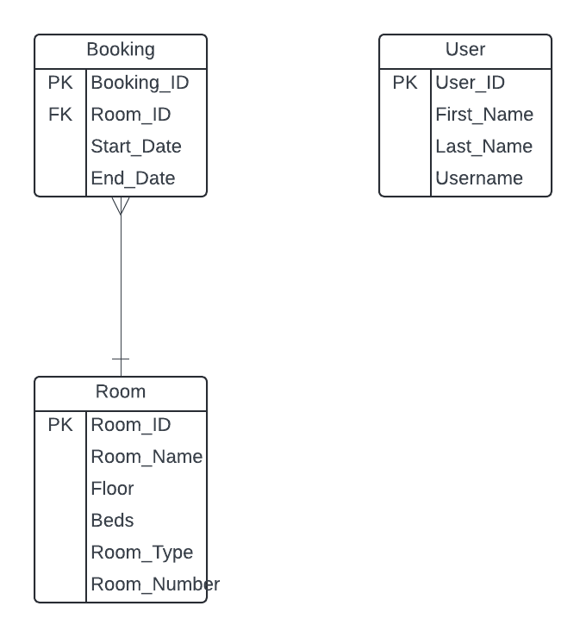

* Tables
  + Room
  + Hotel
    - Location
    - Rating
  + Booking
    - Date
    - Payment_Option
    - View
    - Beds
    - Rate
    - FK Room
    - FK Hotel
    - FK User
  + User/Admin
* Classes
  + Room
    - Penthouse
    - Single
    - Twin
  + User
    - Admin
* CRUD Functions
  + Admin:
  + User class can do:
    - create_table()
    - create_booking()
    - create_customer_info
* Other Functions
  + Python

# 